

**Introduction to Software Engineering**

**Software Requirements Specification  
Document**

  
  
**Group members :**Merjem Qazimi

Xhekiona Bejko

Dea Hoxhaj

Amanta Musaj

Xhejson Muharremi

**Table of Contents**

**1. Introduction**

a. Purpose

b. Objectives

c. Stakeholders

**2. Overall Description**

a. Product perspective

b. Product functions

c. Technologies Used

**3. Process Model**

a. Model Description

b. Framework Activities

c. Actions

d. Tasks

**4. Requirements**

a. Functional Requirements

b. Non-Functional Requirements

**5. Requirements Models**

a. Scenario-based (UML use-case diagram)

b. Class-based (UML class diagram)

**6. System Architecture and System Design**

a. Stepwise Refinement Approach

b. Architectural Style

c. Architectural Context Diagram (ACD)

**7. User Interface Specifications**

**8. Project Management**

a. Feasibility Study

**9. Software Testing**

a. Testing Strategy (Black- Box or White-Box)

b. Testing Technique

c. Testing Tool/s

d. Acceptance Criteria and Testing Results

**10. History of Work, Current Status, and Future Work**

**11. Conclusions**

**12. References**

**1. Introduction**

1.1 Purpose

The primary aim of this project overview is to define the scope and goals of the proposed software enhancements for Netflix. It serves to provide clarity on the intended direction and outcomes of the project, guiding all stakeholders towards a common understanding.

1.2 Objectives

The objectives of this Netflix software enhancement initiative include:

* Documentation: To comprehensively document the objectives, requirements, and processes of the Netflix enhancement initiative for clarity and reference.
* Communication: To facilitate clear and effective communication among stakeholders by providing a detailed understanding of the project's goals and progress.
* Guidance: To serve as a guide for project team members, helping them understand their roles, responsibilities, and the overall project direction.
* Decision-making: To support informed decision-making by presenting relevant information on project feasibility, progress, and outcomes.
* Evaluation: To enable the evaluation of the project's success by documenting key milestones, deliverables, and performance metrics.
* Continuity: To ensure continuity by providing a record of project history, current status, and future work directions for reference in subsequent phases or similar initiatives.

1.3 Stakeholders

The key stakeholders involved in the development and use of the Netflix platform include:

**Users:** Individuals subscribing to Netflix to access its content library.

**Development Team**: Engineers and developers responsible for creating, maintaining, and updating the platform.

**Content Providers:** Studios, production companies, and distributors supplying content to be streamed on Netflix.

**Management**: Executives and decision-makers overseeing the strategic direction and operations of the platform.

**Regulatory Bodies**: Government agencies or organizations overseeing compliance with legal and industry standards.

**Partners: Businesses** collaborating with Netflix to offer bundled services or promotional deals.

The success of the Netflix platform relies on understanding and meeting the needs of these stakeholders, shaping its features and content offerings to deliver a compelling and rewarding entertainment experience.

**2. Overall Description**

***a. Product perspective***

Product Overview: Netflix is a subscription-based streaming service offering a vast library of movies, TV shows, documentaries, and original content. It provides on-demand access through various internet-connected devices, reshaping the entertainment industry by promoting binge-watching and challenging traditional broadcast and cable TV models.

**Context & Scope:**

* Industry: Digital entertainment.
* Competition: Amazon Prime Video, Disney+, Hulu, and traditional TV networks.
* Service Scope: Content acquisition, original content production, content licensing, streaming technology, user experience design, and customer support.
* Global Reach: Available in over 190 countries with region-specific content licensing agreements.

**Product Requirements:**

* Content Discovery: Allow users to browse by genre, category, and personalized recommendations.
* Streaming Experience: Ensure seamless playback and high-quality streaming.
* Account Management: Enable profile creation, subscription management, and parental controls.
* Offline Viewing: Allow downloading of select titles for offline viewing.

***b. Product functions***

1. **Content Streaming**: Access a vast library of movies, TV shows, and original content across multiple devices.
2. **Personalized Recommendations**: Receive tailored suggestions based on viewing history, preferences, and ratings.
3. **Content Discovery**: Browse and search for content by genre, category, language, and more.
4. **User Profiles**: Create multiple profiles within a single account, each with personalized recommendations.
5. **Offline Viewing:** Download select titles for offline viewing, enabling entertainment without an internet connection.
6. **Playback Controls**: Control playback functions like play, pause, rewind, and skip, with subtitle and audio language options.
7. **Continue Watching**: Seamlessly resume playback from where you left off across devices.
8. **Parental Controls**: Set up restrictions based on content maturity ratings and protect access with a PIN.
9. **Content Ratings and Reviews:** View ratings and reviews to make informed decisions about what to watch.
10. **Notifications and Recommendations**: Receive notifications about new releases and personalized recommendations.
11. **Account Management**: Manage account settings, subscription plans, payment methods, and email preferences.
12. **Accessibility Features**: Access closed captions, audio descriptions, and language options for users with disabilities.

***c. Technologies Used***

|  |  |  |
| --- | --- | --- |
| Category | Technologies | Purpose |
| Database | Amazon DynamoDB, Apache Cassandra | Data storage for user profiles |
| Data Processing | Apache Kafka, Apache Flink, Apache Spark | Real-time data processing for content recommendations, big data analysis |
| Real-time Analytics | Apache Kafka, Apache Pinot, Druid | Real-time analytics for user behavior |
| Content Delivery | Amazon CloudFront, AWS Elastic Load Balancing | Content Delivery Network (CDN) for caching content globally |
| Cloud Infrastructure | Amazon Web Services (AWS) | Elastic scaling and hosting infrastructure |
| Web Server & Load Balancer | NGINX, AWS Elastic Load Balancing | Load balancing and routing incoming requests |
| Security | HTTPS, Digital Rights Management (DRM) | Encryption protocol for data security, protection of content |
| Programming Language | Python | Execution of various technologies including Machine Learning and AI |
| AI Technologies | Machine Learning, Artificial Intelligence (AI) | Personalization of content recommendations, optimization of video delivery |

**3. Process Model**

1. Model Description

**Incremental Model**

Continuous Delivery: The Incremental Model divides the development process into small, manageable increments. Each increment adds new functionality to the software, allowing for continuous delivery of updates and improvements. This aligns well with Netflix's approach of frequently releasing new features, optimizations, and content to its platform.

Flexibility and Adaptability: The Incremental Model allows for flexibility and adaptability, enabling Netflix to respond quickly to market changes and user feedback. Netflix can prioritize and implement new features incrementally based on user demand and emerging trends, ensuring that its platform remains competitive and engaging.

Risk Management: By breaking down the development process into increments, the Incremental Model helps mitigate risks associated with large-scale development projects. Netflix can validate assumptions, test new features, and gather feedback at each increment, reducing the likelihood of major setbacks or failures.

Iterative Improvement: The Incremental Model supports an iterative approach to development, where each increment builds upon the previous one. This iterative nature enables Netflix to continuously improve its platform, addressing user needs and enhancing the overall user experience over time.

Overall, the Incremental Model offers the flexibility, agility, and iterative approach that are essential for a dynamic and evolving platform like Netflix. While the specific development processes used by Netflix may vary, the Incremental Model provides a hypothetical framework that reflects the company's emphasis on continuous improvement and innovation.

1. **Framework Activities**

1. Requirements Elicitation and Analysis:

- Identify and gather requirements from stakeholders, including users, content creators, and administrators.

- Analyze and prioritize requirements based on their importance and feasibility for implementation.

2. Increment Planning

- Plan the scope and content of each increment based on the prioritized requirements.

- Define the objectives, deliverables, and timelines for each increment.

- Allocate resources and assign tasks to team members for implementing the planned features.

3. Incremental Development

- Develop the features and functionalities identified in the increment plan.

- Design and implement software components iteratively, focusing on delivering value with each increment.

- Conduct regular reviews and evaluations to ensure that the development progress aligns with the planned objectives.

4. Integration and Testing

- Integrate the developed increments with existing software components and systems.

- Perform integration testing to verify that the integrated components function correctly together.

- Conduct regression testing to ensure that new increments do not introduce defects or regressions in previously implemented features.

5. Deployment and Release

- Deploy the integrated and tested increments to production or staging environments.

- Coordinate with operations teams to ensure smooth deployment and minimal disruption to users.

- Monitor system performance and user feedback after deployment to identify any issues or areas for improvement.

6. Feedback and Evaluation:

- Gather feedback from users, stakeholders, and operational teams on the deployed increments.

- Evaluate the success of each increment based on predefined criteria, such as user satisfaction, performance metrics, and business objectives.

- Use feedback and evaluation results to inform future increment planning and refinement of the development process.

7. Maintenance and Evolution

- Address any issues or bugs identified during deployment and user feedback.

- Plan and prioritize enhancements and updates for future increments based on evolving requirements and market trends.

- Continuously monitor and maintain the software to ensure its stability, security, and scalability over time.

1. **Actions**

- **Requirements Gathering**

- Conduct stakeholder interviews

- Analyze existing documentation

- Create use cases or user stories

**- Design:**

- Define system architecture

- Design database schema

- Create wireframes or prototypes

- **Implementation:**

- Write code according to design specifications

- Conduct code reviews

- Perform unit testing

- **Testing:**

- Develop test cases

- Execute functional, integration, and performance tests

- Document and prioritize defects

- **Deployment**

- Plan and execute deployment strategy

- Monitor system during deployment

- Conduct user training, if necessary

**-Maintenance**

- Address reported issues and bugs

- Implement enhancements and new features

- Perform regular system updates and optimizations

**d. Tasks**

**- Write code according to design specifications:**

- Implement algorithms

- Create classes and functions

- Handle error cases and edge conditions

**- Develop test cases**

- Identify test scenarios

- Write test scripts

- Define expected outcomes

**- Plan and execute deployment strategy**

- Coordinate with operations team

- Prepare deployment packages

- Schedule downtime, if required

**4. Requirements**

**Functional** **requirements**

**1. User Management**

* The system must allow users to create and manage their profiles.
* Users must be able to update their personal details such as name, email, and password.
* Users can add or remove profiles associated with their account.

**2. Profile Management**

* Each user profile must be able to maintain a list of recommended content and a watchlist.
* Profiles should have unique identifiers and names.

**3. Content Management**

* The system must manage different types of content, including movies and series.
* For series, the system should handle multiple episodes under a single series.

**4. Subscription Management**

* The system must manage user subscriptions, including the type and price of the subscription.
* Users must be able to set and update their payment methods.

**5. Settings Management**

* Users must be able to configure account settings, privacy settings, notification settings, and playback settings.
* Account settings should include theme and language preferences.
* Privacy settings should handle viewing history visibility, sharing preferences, and data collection preferences.
* Notification settings should allow toggling email, push, and in-app notifications.
* Playback settings should manage playback speed, player preferences, and parental controls.

**6. Viewing History**

* The system must maintain a viewing history for users, tracking the content they have watched.
* Users should be able to add or remove titles from their viewing history.

**7. Recommendation Engine**

* The system must provide personalized content recommendations based on user profiles and viewing history.

**Non-Functional Requirements**

**Performance**

The system should handle multiple concurrent users without significant performance degradation.

Content recommendations should be generated quickly to provide a seamless user experience.

Scalability

The system must be able to scale to accommodate an increasing number of users and content.

**Security**

User data, especially personal and payment information, must be stored securely.

The system should implement strong authentication and authorization mechanisms.

**Usability**

The user interface should be intuitive and easy to navigate.

Users should be able to easily manage their profiles, settings, and subscriptions.

**Reliability**

The system should have a high uptime, ensuring that services are available to users at all times.

**Data consistency must be maintained across all components of the system.**

**Maintainability**

The codebase should be modular and well-documented to facilitate maintenance and future enhancements.

The system should support easy updates and deployment.

**Compliance**

The system must comply with relevant data protection regulations (e.g., GDPR, CCPA).

User privacy preferences should be honored as per the configured settings.

By addressing these functional and non-functional requirements, the system can effectively support the functionalities represented in the UML diagram and provide a robust user experience.

**5. Requirements Models**

a. Scenario-based (UML use-case diagram)

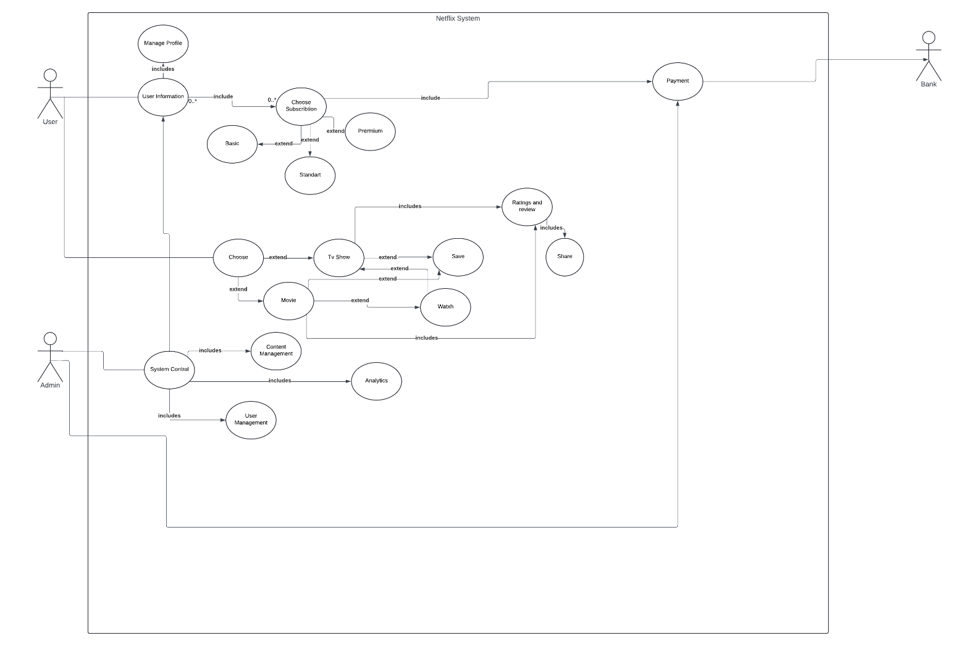

b. Class-based (UML class diagram

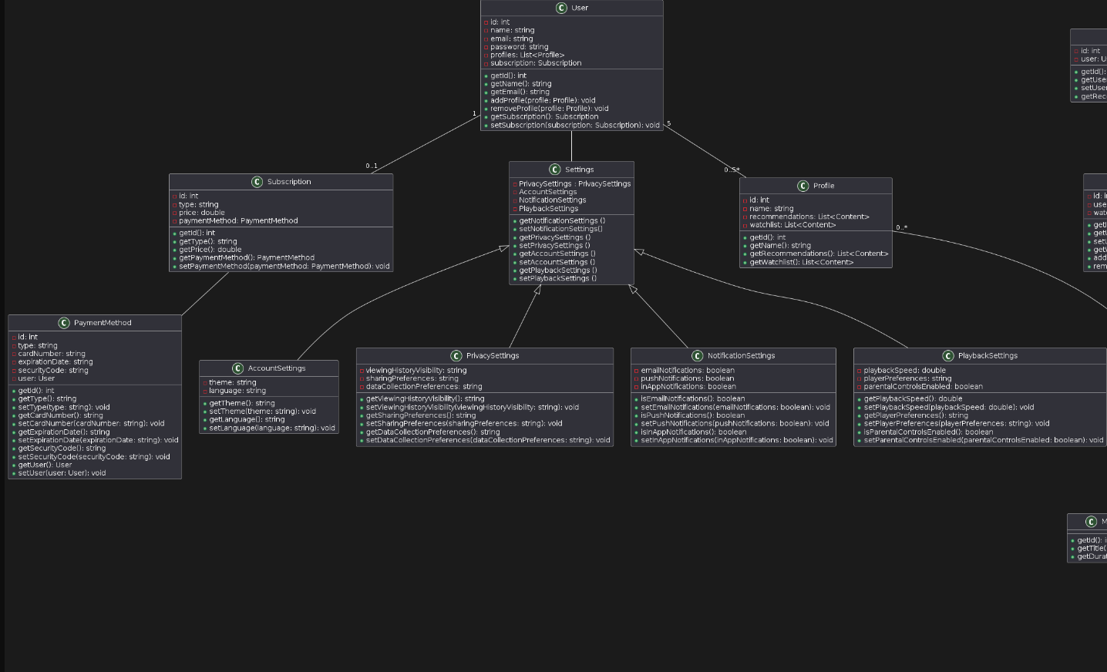

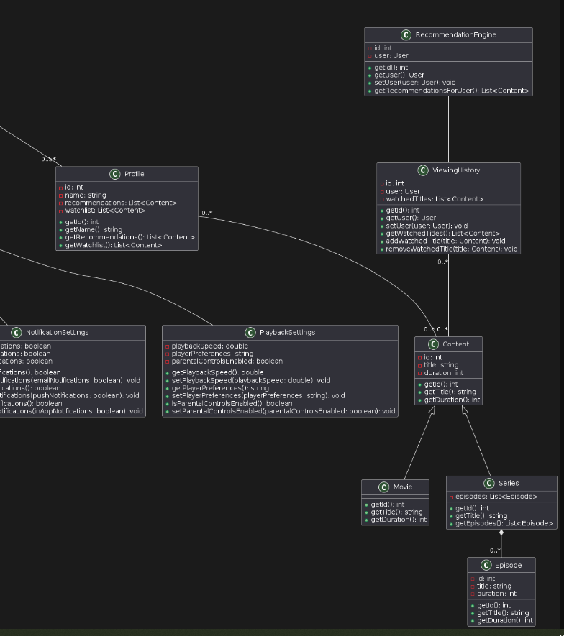

CRC model

User

**Responsibilities:**

Manage user information.

Manage user profiles and subscriptions.

Manages settings

**Collaborators:**

Profile: Manages user profiles.

Subscription: Manages user subscriptions.

Settings

Profile

**Responsibilities:**

Manage profile information (name, recommendations, watchlist).

Manages the content

**Collaborators:**

User: Belongs to a user and is managed by the user.

Content

Content

**Responsibilities:**

Manage content information (title, duration) and viewing history of the user

**Collaborators:**

Profile

Viewing history

Movie

**Responsibilities:**

Manage movie information (title, duration).

**Collaborators:** Inherits from Content.

Series

**Responsibilities:**

Manage series information (title, episodes).

**Collaborators:** Inherits from Content.

episode

Episode

**Responsibilities:**

Manage episode information (title, duration).

**Collaborators**: series

Subscription

**Responsibilities:**

Manage subscription information (type, price, payment method).

**Collaborators:**

* User
* PaymentMetho

PaymentMethod

**Responsibilities:**

Manage payment method information (type, card number, expiration date, security code).

**Collaborators:**

Subscription

Settings

**Responsibilities:**

Manage user settings (privacy, account, notification, playback).

**Collaborators:**

* AccountSettings:
* PrivacySettings
* NotificationSettings
* PlaybackSettings

**AccountSettings**

**Responsibilities:**

Manage account settings information (theme, language).

**Collaborators:**

* Settings

**PrivacySettings**

**Responsibilities:**

Manage privacy settings information (viewing history visibility, sharing preferences, data collection preferences).

**Collaborators:**

Settings

NotificationSettings

Responsibilities:

Manage notification settings information (email notifications, push notifications, in-app notifications).

Collaborators:

Settings

**PlaybackSettings**

Responsibilities:

Manage playback settings information (playback speed, player preferences, parental controls enabled).

Collaborators:

Settings

**ViewingHistory**

Responsibilities:

Manage viewing history information (watched titles).

Collaborators:

RecommendationEngin

Content

**RecommendationEngine**

Responsibilities:

Generate recommendations for users based on their viewing history.

Collaborators:

ViewingHistory: Uses viewing history to generate recommendations.

6. System Architecture and System Design

**Apply a “stepwise refinement approach” to develop three different levels of abstractions for Netflix.**

**Stepwise Refinement Approach for Netflix:**

**Level 1 Abstraction: High-Level Overview**

* Content Management
* User Interface
* Recommendation System
* Streaming Infrastructure
* User Accounts and Profiles
* Payment and Subscription Management

**Level 2 Abstraction: Subsystems Content Management:**

* Content Acquisition
* Content Categorization
* Content Delivery
* Content Licensing

**User Interface:**

* Browsing Interface
* Playback Interface
* Search Functionality
* Personalization Features

**Recommendation System:**

* Content Recommendation Algorithms
* User Preference Tracking
* Collaborative Filtering Techniques

**Streaming Infrastructure:**

* Content Delivery Network (CDN)
* Video Encoding and Decoding
* Adaptive Bitrate Streaming

**User Accounts and Profiles:**

* User Registration
* Account Settings
* Profile Creation and Management
* Multiple Profiles per Account

**Payment and Subscription Management:**

* Subscription Plans
* Payment Gateway Integration
* Billing Management
* Subscription Renewal and Cancellation

**Level 3 Abstraction: Low level (Detailed Description) Content Management:**

* **Content Acquisition:**
  + Negotiates and acquires rights to stream content from various studios and content creators.
  + Manages contracts, licensing agreements, and content libraries.
* **Content Categorization:**
  + Tags and categorizes content based on genre, language, release year, etc., for efficient search and recommendation.
* **Content Delivery:**
  + Deploys servers and CDN nodes worldwide to ensure fast and reliable content delivery to users.
  + Implements caching strategies to optimize bandwidth usage and reduce latency.
* **Content Licensing:**
  + Tracks content licensing agreements, renewal dates, and payment schedules.
  + Manages content availability based on licensing restrictions and regional rights.

**User Interface:**

* **Browsing Interface:**
  + Presents users with a visually appealing and intuitive interface for browsing content.
  + Organizes content into categories, rows, and personalized recommendations.
* **Playback Interface:**
  + Provides controls for playing, pausing, rewinding, and skipping content.
  + Offers features such as subtitles, audio language selection, and video quality settings.
* **Search Functionality:**
  + Implements a search engine to allow users to find specific titles quickly.
  + Supports keyword search, filters, and autocomplete suggestions.
* **Personalization Features:**
  + Analyzes user viewing history, ratings, and preferences to personalize recommendations.
  + Customizes the user interface based on individual user profiles.

**Recommendation System:**

* **Content Recommendation Algorithms:**
  + Utilizes machine learning algorithms to predict user preferences and recommend relevant content.
  + Factors in user behavior, demographics, and contextual information for accurate recommendations.
* **User Preference Tracking:**
  + Tracks user interactions, such as watched content, ratings, and searches, to update user preferences dynamically.
* **Collaborative Filtering Techniques:**
  + Incorporates collaborative filtering methods to recommend content based on similarities with other users' preferences.

**Streaming Infrastructure:**

* **Content Delivery Network (CDN):**
  + Distributes content across geographically distributed CDN nodes for efficient delivery.
  + Balances traffic load and redirects users to nearby servers for optimal streaming performance.
* **Video Encoding and Decoding:**
  + Transcodes video content into multiple formats and bitrates to support various devices and network conditions.
  + Optimizes video compression to maintain quality while minimizing bandwidth usage.
* **Adaptive Bitrate Streaming:**
  + Dynamically adjusts video quality based on network bandwidth and device capabilities to ensure smooth playback.

**User Accounts and Profiles:**

* **User Registration:**
  + Manages user registration process, including email verification and account activation.
  + Stores user credentials securely and handles authentication requests.
* **Account Settings:**
  + Allows users to customize account settings, such as language preferences, playback settings, and parental controls.
* **Profile Creation and Management:**
  + Enables users to create multiple profiles within a single account for personalized recommendations and viewing history.
  + Allows profile management, including profile picture upload, name changes, and content restrictions.
* **Multiple Profiles per Account:**
  + Supports the creation of separate profiles for different family members or household members.
  + Maintains separate viewing history, preferences, and recommendations for each profile.

**Payment and Subscription Management:**

* **Subscription Plans:**
  + Offers multiple subscription tiers with different pricing and feature sets.
  + Displays subscription options and benefits to users during the sign-up process.
* **Payment Gateway Integration:**
  + Integrates with payment gateways to process subscription payments securely.
  + Supports various payment methods, such as credit/debit cards, PayPal, and direct debit.
* **Billing Management:**
  + Manages billing cycles, invoicing, and payment processing for subscription renewals.
  + Sends billing notifications and reminders to users before subscription expiration.
* **Subscription Renewal and Cancellation:**
  + Automatically renews subscriptions based on user preferences and payment methods.
  + Allows users to cancel subscriptions at any time and provides options for refund requests.

1. **What architectural style(s) do you believe would be most appropriate for implementing Netflix?**

Netflix’s architectural style is built as a collection of services, following a **microservices architecture**. [This approach involves breaking down the system into small, independent services that can be developed, deployed, and scaled autonomously1](https://www.geeksforgeeks.org/system-design-netflix-a-complete-architecture/).

**High-Level Design of Netflix System:**

* + **Client (Device/User Interface):** This component includes devices like TVs, Xbox, laptops, and mobile phones. Users browse and play Netflix videos using these interfaces.
  + **Open Connect (OC) or Netflix CDN:** The custom global CDN (Content Delivery Network) handles video streaming. It consists of distributed servers in various geographical locations. When you hit the play button, the video stream is served from the nearest Open Connect server, ensuring faster response times.
  + **Backend (Database):** This part manages everything before video streaming begins. [It handles onboarding new content, video processing, distributing videos to servers worldwide, and managing network traffic1](https://www.geeksforgeeks.org/system-design-netflix-a-complete-architecture/).

**3. Create an Architectural Context Diagram for Google Classroom.**

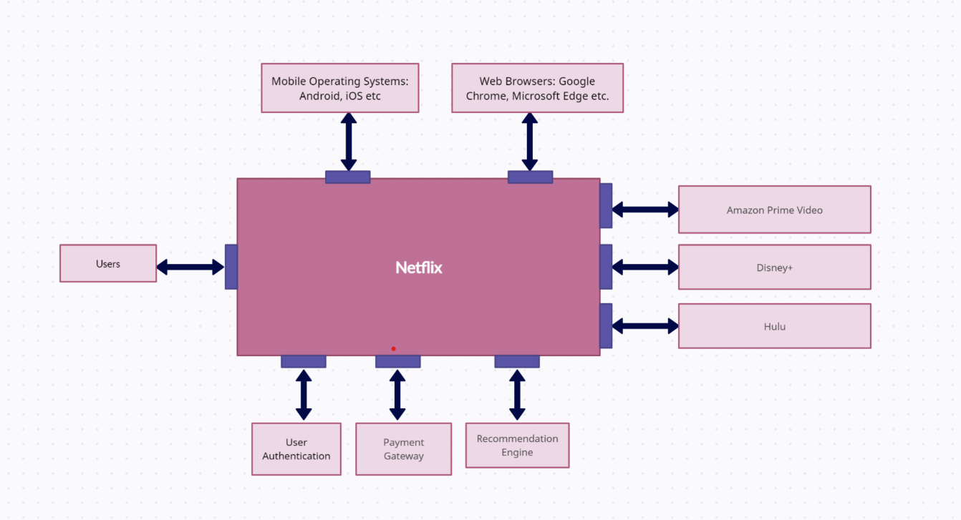Let's expand the Architectural Context Diagram (ACD) for Netflix to include subordinate and peer-level systems:

**7. User Interface Specifications**

**User Interface Specification – Netflix**

1. **Visual Design Guidelines:**
   * Layout: Utilize a visually appealing and intuitive layout with clear sections for browsing content, user profiles, search functionality, and account settings.
   * Typography: Implement Netflix's recommended fonts for readability and consistency across various devices and screen sizes.
   * Color Scheme: Adhere to Netflix's branding colors while ensuring a visually engaging experience. Use colors strategically to highlight featured content and distinguish different genres or categories.
   * Icons and Graphics: Integrate icons and graphics judiciously to assist navigation and enhance the visual appeal of the interface without overwhelming the user.
2. **Interaction Design Requirements:**
   * Navigation: Provide easy access to key features such as browsing, searching, viewing history, and managing profiles through an intuitive and hierarchical menu structure.
   * User Interface Controls: Design intuitive controls for actions like playing content, adding to watchlist, rating shows, managing subscriptions, and adjusting playback settings.
   * Feedback Mechanisms: Offer clear feedback through visual cues, notifications, and progress indicators to enhance user understanding and engagement.
   * Form Design: Design input forms with clear labels, error handling, and validation cues to facilitate smooth account registration, payment, and preferences customization.
3. **Accessibility Guidelines**:
   * Keyboard Navigation: Ensure all features and functionalities are accessible via keyboard navigation to accommodate users with motor disabilities.
   * Screen Reader Compatibility: Ensure compatibility with screen readers to provide auditory feedback for users with visual impairments.
   * Color Contrast: Maintain sufficient color contrast ratios to enhance readability and ensure content accessibility for users with visual impairments.
   * Alternative Text: Provide descriptive alternative text for non-text content like images and icons to enable understanding for users with screen readers or images disabled.
4. **Responsive Design Standards:**
   * Desktop Layout, Mobile Layout, Tablet Layout: Design responsive layouts that adapt seamlessly to different screen sizes and orientations, prioritizing content accessibility and usability across devices.
5. **Usability Standards:**
   * Simplicity: Prioritize simplicity in interface design to minimize cognitive load and make it easy for users to browse, search, and watch content on Netflix.
   * Clarity: Ensure clarity in interface elements, labels, and instructions to facilitate user comprehension and reduce confusion while navigating the platform.
   * Consistency: Maintain consistency in design patterns, terminology, and interaction flows to enhance learnability and user confidence across different parts of the Netflix experience.
   * User Feedback: Incorporate feedback mechanisms to gather user input, address user needs, and continuously improve the user experience through iterative design updates and content recommendations.

**8. Project Management**

a. Feasibility Study

**1. Technical Feasibility**

**Scalability:** Netflix employs a microservices architecture that allows it to handle massive workloads and millions of concurrent users. The use of cloud services (AWS) and a robust Content Delivery Network (CDN) ensures that Netflix can scale horizontally by adding more servers and services as needed without significant performance degradation.

**Performance:** Netflix is known for its high performance, offering quick load times, seamless video playback, and minimal buffering. Continuous monitoring and optimization efforts help identify and resolve performance bottlenecks. Netflix's adaptive streaming technology adjusts video quality based on the user's internet speed, ensuring an optimal viewing experience.

**Reliability:** Netflix ensures high reliability with an impressive uptime record. The use of multiple data centers, redundant systems, and disaster recovery protocols contribute to fault tolerance and resilience. Netflix's Chaos Engineering practices, such as the Chaos Monkey tool, test system resilience to failures, ensuring reliability.

**Security:** Netflix implements strong security measures, including encryption, secure coding practices, and regular security audits. Compliance with industry standards like ISO 27001 and NIST, alongside robust access controls and threat detection systems, protect against unauthorized access and data breaches.

**2. Economic Feasibility**

**Total Cost of Ownership (TCO):** The TCO for Netflix includes expenses related to cloud infrastructure, content acquisition, technology development, licensing, and employee salaries. Additionally, costs for marketing, customer support, and maintenance are substantial. However, economies of scale help manage these costs effectively.

* Content Acquisition and Production Costs: Netflix's content budget for 2023 was estimated at approximately $17 billion. This includes both licensed content and original productions.
* Technology and Infrastructure Costs: Netflix's expenditure on cloud services, primarily with AWS, is substantial. While specific figures are proprietary, estimates suggest annual costs could be in the range of $1 billion to $2 billion.
* Operational Costs: These include salaries, marketing, customer support, and other operational expenses. For 2023, Netflix's operating expenses were around $7 billion.
* Maintenance and Support: Ongoing maintenance and support for its technology infrastructure and customer service could account for an additional $1 billion annually.

**Return on Investment (ROI):** Netflix's ROI is significant, driven by subscription revenues, strategic investments in original content, and global market expansion. The company's ability to retain subscribers and attract new ones through a rich content library and personalized recommendations contributes to high ROI.

* Revenue: In 2023, Netflix reported annual revenues of approximately $31.6 billion, driven primarily by subscription fees.
* Profit Margins: Netflix's operating income for 2023 was around $6.5 billion, reflecting a healthy profit margin driven by its efficient operations and content strategy.

**Cost-Benefit Analysis:** The financial benefits of Netflix, such as substantial revenue from subscriptions and potential advertising models, outweigh the costs of operation and content creation. The continuous growth in subscriber base and expansion into new markets ensure that the benefits significantly exceed the costs.

* Benefits: Benefits include substantial revenue from subscription fees and the value of brand equity and customer loyalty. With a global subscriber base exceeding 230 million, the revenue generation potential is significant.
* Costs: Annual costs include the above-mentioned content production, technology, operational expenses, and maintenance, totaling around $27 billion.

**Potential Cost Savings/Revenue Generation:** Netflix can generate revenue through various channels, including subscription fees, licensing deals, and potential ad-supported tiers. Cost savings can be realized through optimized content delivery, automation in customer support, and strategic partnerships for content production.

* Advertising Revenue: With the introduction of an ad-supported tier, Netflix is expected to generate additional revenue streams. Analysts estimate this could add up to $2 billion annually in advertising revenue within a few years.
* Efficiency Gains: Investment in AI and machine learning for personalized recommendations and operational efficiencies could save hundreds of millions annually in marketing and customer retention costs.

**3. Operational Feasibility**

**Usability:** Netflix offers a highly user-friendly interface, with intuitive navigation, personalized recommendations, and cross-platform accessibility. High user satisfaction is evident from its vast subscriber base and low churn rates.

**Alignment with Business Processes:** Netflix's software aligns well with its business processes, including content acquisition, streaming, and customer support. Advanced data analytics and machine learning models support personalized content recommendations, enhancing user engagement.

**Ease of Maintenance:** The use of microservices architecture facilitates easier maintenance and updates. Regular updates, bug fixes, and new feature rollouts are streamlined. Technical support is robust, ensuring minimal downtime and prompt resolution of issues.

**Ability to Support Organizational Goals:** Netflix's software supports its strategic goals of global expansion, content diversification, and customer satisfaction. Innovations like interactive storytelling (e.g., "Black Mirror: Bandersnatch") and investments in local content bolster its market position and brand loyalty.

**4. Legal and Regulatory Compliance**

**Data Protection Laws:** Netflix complies with GDPR for European users, CCPA for Californian users, and other relevant data protection regulations. Measures include transparent data usage policies, user consent for data processing, and robust data security practices.

**Industry Regulations:** Netflix adheres to industry-specific regulations, such as content rating systems (e.g., MPAA ratings), and ensures compliance with streaming and broadcasting standards. Financial reporting complies with regulations like SOX, ensuring transparency and accountability.

**Intellectual Property Rights:** Netflix holds the necessary intellectual property rights for its original content and has licensing agreements for third-party content. Legal teams ensure protection against infringement and manage copyright issues effectively.

Top of Form

9. Software Testing **Black Box Testing Approach for Netflix**

**1. User Authentication:**

* **Objective:** Validate the functionality of user authentication features.
  + Test user sign-up process: Ensure users can successfully create accounts with valid information.
  + Test user login process: Verify that users can log in using their credentials.
  + Test password reset functionality: Ensure users can reset their passwords securely.
  + Test account management features: Verify that users can edit their profiles and manage their subscriptions.

**2. Content Discovery and Recommendation:**

* **Objective:** Validate the functionality of content discovery and recommendation features.
  + Test search functionality: Verify that users can search for movies and TV shows across different genres, languages, and categories.
  + Test personalized recommendations: Validate that users receive accurate and relevant recommendations based on their preferences and viewing history.
  + Test browsing experience: Ensure smooth navigation and user experience while browsing content.

**3. Video Streaming and Playback:**

* **Objective:** Validate the functionality of video streaming and playback features.
  + Test video streaming across devices: Verify that users can stream content seamlessly across various devices and platforms.
  + Test playback controls: Ensure that users can control playback (play, pause, seek) and adjust subtitle/audio language options.
  + Test video quality: Verify that Netflix adjusts video quality based on network conditions for uninterrupted viewing experience.

**4. Billing and Subscription Management:**

* **Objective:** Validate the functionality of billing and subscription management features.
  + Test subscription sign-up process: Verify that users can sign up for subscriptions and make payments securely.
  + Test subscription management: Ensure users can easily upgrade, downgrade, or cancel their subscription plans.
  + Test billing accuracy: Validate that billing cycles are accurate, and invoices are generated correctly.

**Conclusion:**

Black box testing is a suitable approach for Netflix as it focuses on testing the functionality of the application from an end-user perspective. By conducting thorough black box testing, you can ensure that Netflix meets its functional requirements and provides a seamless experience to its users.

10. History of Work, Current Status, and Future Work

**History of Work:**

Netflix originated in 1997 when Reed Hastings and Marc Randolph founded it as a DVD rental service. Their concept was to offer a convenient alternative to traditional video rental stores by enabling customers to order DVDs online for delivery via mail. The company's focus then shifted in 2007 with the introduction of its streaming service, which allowed subscribers to stream movies and TV shows directly to their devices over the internet. This transition marked a significant shift for Netflix and laid the groundwork for its subsequent dominance in the streaming industry.

Since then, Netflix has evolved into one of the world's premier streaming platforms, boasting a vast library of content spanning movies, TV shows, and original productions. Its reach has extended globally, with millions of subscribers across more than 190 countries.

Today, Netflix provides users with a user-friendly platform packed with features aimed at enhancing the streaming experience. Subscribers can explore a diverse range of content across different genres and languages. Netflix leverages sophisticated algorithms to tailor recommendations for each user based on their viewing history, preferences, and ratings. Additionally, the platform supports multiple user profiles within a single account, ensuring personalized recommendations for each member of the household.

In addition to streaming, Netflix offers offline viewing capabilities, enabling users to download selected titles for offline consumption. The platform also supports high-definition streaming, including 4K Ultra HD and HDR content, for an immersive viewing experience.

Accessible on various devices such as smart TVs, streaming media players, gaming consoles, smartphones, and tablets, Netflix provides flexible subscription plans tailored to users' preferences in terms of streaming quality and simultaneous streams.

Looking ahead, Netflix remains committed to innovation, continuously exploring ways to elevate the streaming experience. This includes further enhancing recommendation algorithms for even more personalized content suggestions, experimenting with interactive content formats to engage viewers, expanding its content library and presence in international markets, and embracing emerging technologies like augmented reality (AR) and virtual reality (VR) to push the boundaries of entertainment. These endeavors underscore Netflix's dedication to providing an unparalleled streaming experience while staying at the forefront of technological advancements in the entertainment industry.

**11. Conclusions**

In conclusion, the Netflix project underscores the complexity and strategic considerations inherent in developing a cutting-edge streaming platform. It highlights the critical need for meticulous feasibility studies, taking into account the multifaceted technical, financial, and legal aspects. Moreover, the project underscores the paramount importance of rigorous testing methodologies to ensure the platform's performance, security, and scalability. As Netflix continues to redefine the streaming landscape, this project serves as a testament to the innovation and technical prowess required to deliver a world-class streaming experience.

12. References:

<https://ir.netflix.net/ir-overview/profile/default.aspx>

<https://finance.yahoo.com/quote/NFLX>

<https://gaper.io/netflix-tech-stack-secrets/>

<https://www.practitest.com/>

**Netflix TechBlog:** The Netflix TechBlog is an excellent resource for understanding the technical aspects of Netflix’s systems. You can find detailed articles on various topics related to their architecture, scalability, and engineering practices. Visit the Netflix TechBlog for in-depth insights.

|  |  |  |  |  |
| --- | --- | --- | --- | --- |
| Merjem Qazimi | Xhekiona Bejko | Dea Hoxhaj | Amanta Musaj | Xhejson Muharremi |
| 1.Introduction  5. Requirements Models. B)  8. Project Management | 2. Overall Description9. Software Testing | 4. Requirements  6. System Architecture and System Design | 3. Process Model  10. History of Work, Current Status, and Future Work | 5 a. Scenario-based (UML use-case diagram)  7. User Interface Specifications  11. Conclusions |